Report Title (Segoe UI, 28 pt., Bold)

Subtitle (Calibri, 20 pt., Bold)

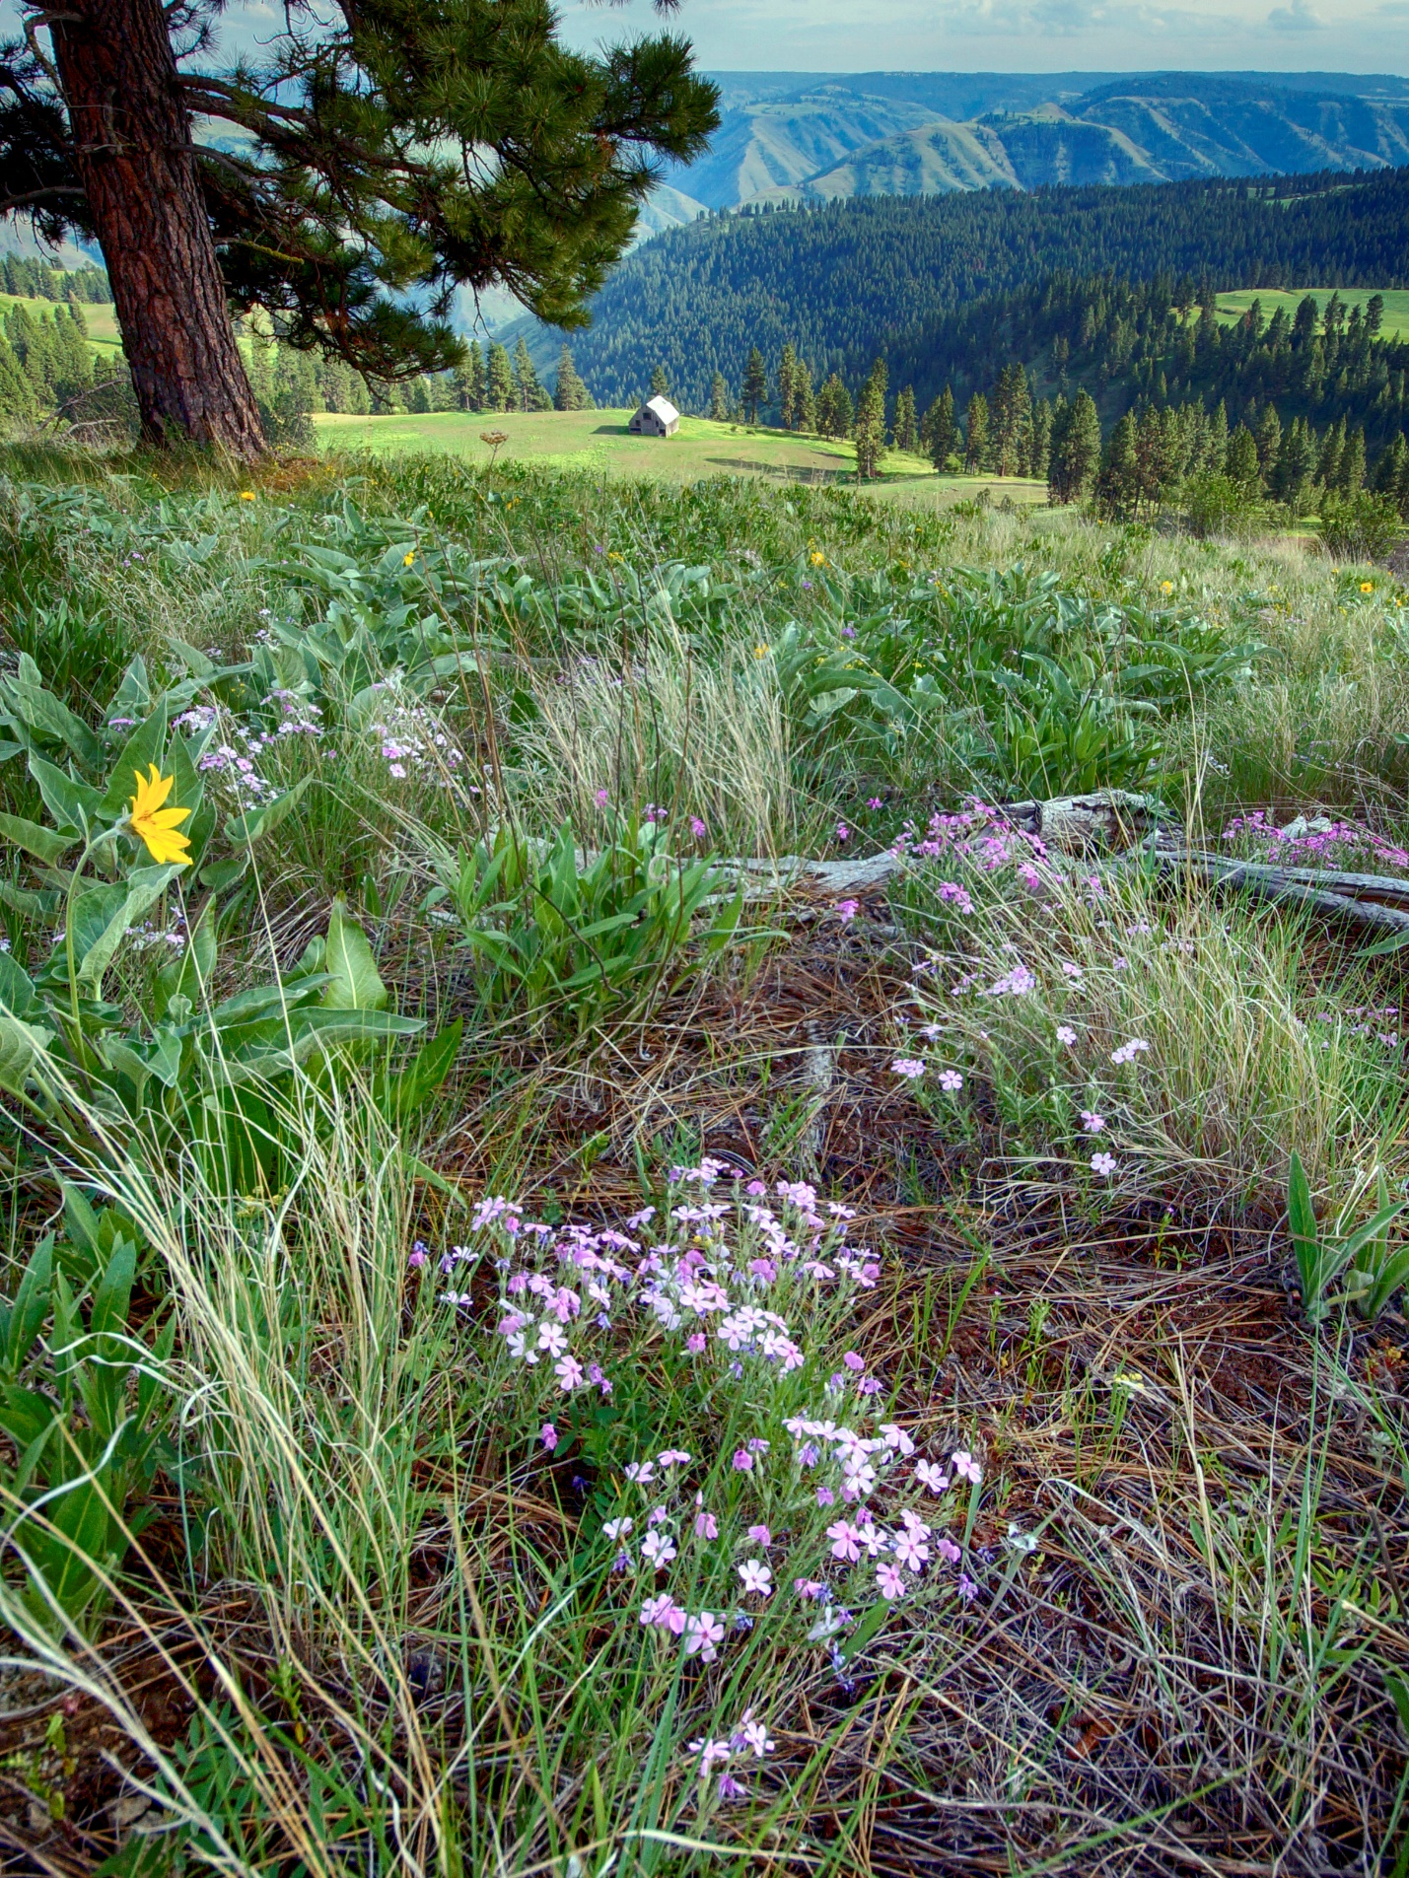

NOTE: Alternative text is needed for all photos. Captions are needed for all photos, except cover images.

# Acknowledging the Indigenous People, Land, and Culture of the Pacific Northwest

Since time immemorial, Indigenous People have graced the Pacific Northwest with rich traditions of many diverse cultures, languages, traditional knowledge expressed artistically and practically with intricate principles passed down throughout generations. As the first stewards of this land, Indigenous People from this part of the world are ancestrally engrained in the very fabric of this region that is known today as Washington State.

Washington Department of Fish and Wildlife (WDFW) acknowledges the American Indian Tribes as the original occupants of this land enjoyed today by all Washingtonians. Their historic reliance to hunt, fish, and gather traditional foods defines their inherent responsibilities to protect and steward the precious resources on the waters and landscape shared today by all Washington residents.

The very survival of the Pacific Northwest Tribes is a testament of resiliency of what they have endured and continue to endure throughout generations on this very landscape. Through scarred valor, many historical encounters of massacre, renunciation of religious freedom, systemic racism, cultural assimilation of native children through institutional residential schools, and the fight for their inherent rights and liberties, they have prevailed. Throughout this tormented history brought by colonization, abrogated treaties, infringement of civil rights, and the salmon protests of the 1960s, the Northwest Tribes and WDFW have founded a commitment of respect, unity, and alliance taught by the realities of the past.

Today tribal governments and WDFW work collaboratively to conserve and manage aquatic and terrestrial resources across the State and practice sound science to ensure successful resource management decisions. The Tribes and WDFW work together to ensure the sustainability of fish, wildlife, ecosystems, and culture for the next seven generations and beyond.

## When to include this statement

*This WDFW statement respectively acknowledges the tribes we work with, their sovereignty, history, aboriginal culture, and the shared responsibilities in resource management and conservation.*

*This approved statement may be used when there is a tribal nexus on reports, management plans, and other documents with tribal involvement. Additional guidance is available in the WDFW Style Guide (available in 2024).*

Table of Contents

Acknowledging the Indigenous People, Land, and Culture of the Pacific Northwest 1

When to include this statement 1

Main report chapters (Segoe UI, 20 pt., Bold) 3

Heading 2 (Calibri, 16 pt., Bold) 3

Heading 3 (Calibri, 14 pt., Bold) 3

Photo guidance 4

Where to find photos 4

Photo formatting tips 4

Table guidance 5

Table formatting tips 5

Figure guidance 6

Figure formatting tips 6

Literature cited 7

List of Tables

Table 1. Descriptive name 6

Table 2. Another descriptive name 6

List of Figures

Figure 1. Descriptive name 7

Cover photo by [NAME]

Suggested citation

[INSERT CITATION]

Request this information in an alternative format or language at [wdfw.wa.gov/accessibility/requests-accommodation](http://wdfw.wa.gov/accessibility/requests-accommodation), 833-855-1012, TTY (711), or [CivilRightsTeam@dfw.wa.gov](mailto:CivilRightsTeam@dfw.wa.gov).

# Main report chapters (Segoe UI, 20 pt., Bold)

## Heading 2 (Calibri, 16 pt., Bold)

### Heading 3 (Calibri, 14 pt., Bold)

#### Heading 4 (Calibri, 12 pt., Bold)

Body Text (Calibri, 11 pt., 1.15 line spacing)

[Hyperlinks](https://stateofwa.sharepoint.com/sites/DFW-Communications/SitePages/Branded-WDFW-Templates.aspx) (Hyperlink, blue, underlined text)

Quotes and call out text (Quote, Segoe UI Semilight, 16, 1.15 line spacing)

Note: Use the Styles gallery in this template to apply these pre-established font treatments throughout your report.

# **Photo guidance**

## Where to find photos

* Attempt to use WDFW and/or Washington state images whenever possible. Seek assistance from your [communications manager](https://stateofwa.sharepoint.com/sites/DFW-Communications) if you need help locating an image.
* WDFW Media Library: [https://workspace.dfw.wa](https://workspace.dfw.wa.lcl/media/pages/home.php).[lcl/media/pages/home.php](https://workspace.dfw.wa.lcl/media/pages/home.php)

## Photo formatting tips

* Add alt text describing the scene. Right click photo > view alt text > edit.
* Add captions to all photos for context. Cover photos do not need captions. Photo credits are required for non-WDFW photos. Use *Photo caption* style.
* Format photos In Line with Text. Click photo > picture format menu > wrap text > In Line with Text. Left justify small photos. Center large photos.
* Adjust spacing below photos. Click photo > select *Photo spacing* style.

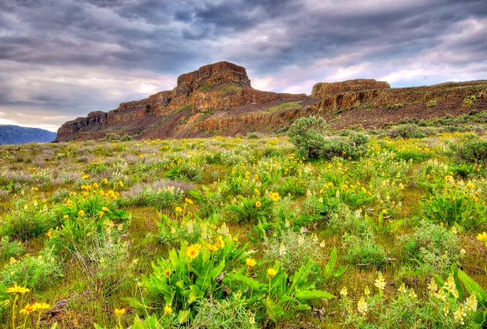

Photo caption. Photo by [NAME].

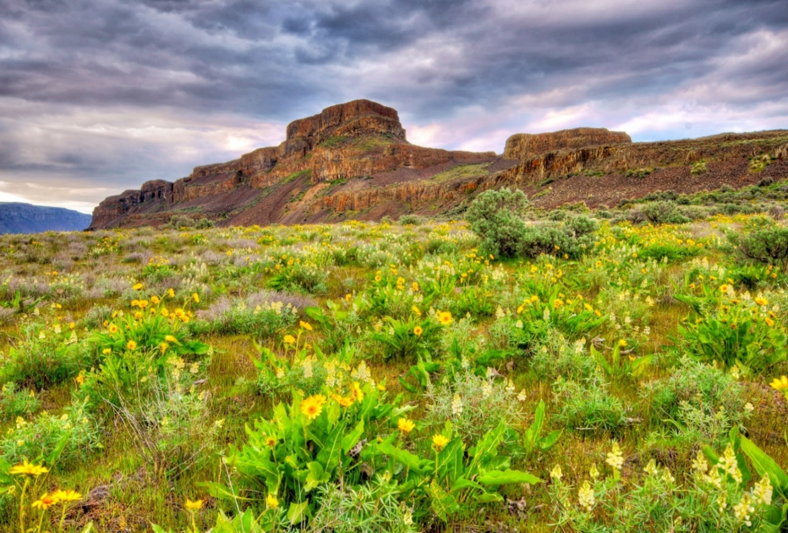

Photo caption. Photo by [NAME].

# **Table guidance**

The most accessible tables will have:

* Column headers, row headers, or both.
* No empty headers.
* Clear and minimal text in each cell.
* No cells or headers that merge to span multiple columns or rows.

## Table formatting tips

This report template contains a built-in table style that is formatted for you. Simply insert a table and add your data. Consider using multiple tables to break down complex information.

Table . Descriptive name

|  |  |  |  |  |
| --- | --- | --- | --- | --- |
| Column 1 | Column 2 | Column 3 | Column 4 | Column 5 |
|  |  |  |  |  |
|  |  |  |  |  |
|  |  |  |  |  |
|  |  |  |  |  |
|  |  |  |  |  |

Table . Another descriptive name

|  |  |  |
| --- | --- | --- |
| Column 1 | Column 2 | Column 3 |
|  |  |  |
|  |  |  |
|  |  |  |
|  |  |  |
|  |  |  |
|  |  |  |

# Figure guidance

The most accessible charts and graphs will have:

* A simple concept and defined purpose.
* Data differentiated by symbols or dashed lines in addition to color.
* Good color contrast.

## Figure formatting tips

* Add alt text describing the scene. Right click figure > view alt text > edit.
* Add captions for context. Use *Photo caption* style.
* Format figures In Line with Text. Click figure > picture format menu > wrap text > In Line with Text. Left justify small figures. Center large figures.
* Adjust spacing below photos. Click figure > select *Photo spacing* style.

Figure . Descriptive name

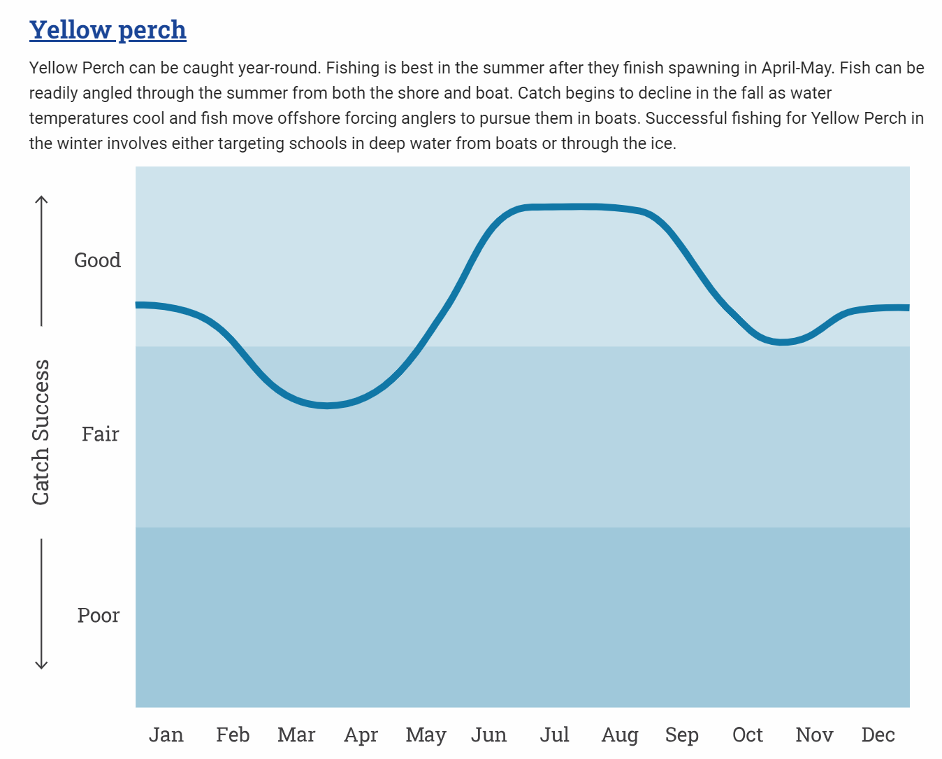

Figure caption.

# Literature cited

Here is where your citations go. Format them using the *Literature citation* style. They will look consistent and fabulous.

Here is where your citations go. Format them using the *Literature citation* style. They will look consistent and fabulous.